**Behold The Coat of Hopes**

The **Coat of Hopes** is a patchwork coat that is on an ongoing walk-through Britain. Made, worn and walked by hundreds of people during and since its pilgrimage from the south coast of England to COP 26, the UN climate summit, in Glasgow autumn 2021.

The Coat is made up of pieces of blanket into which people have worked their griefs, remembrances, prayers and hopes for the place they call home. It carries an invitation to share our love and responsibility in facing this climate and ecological emergency.

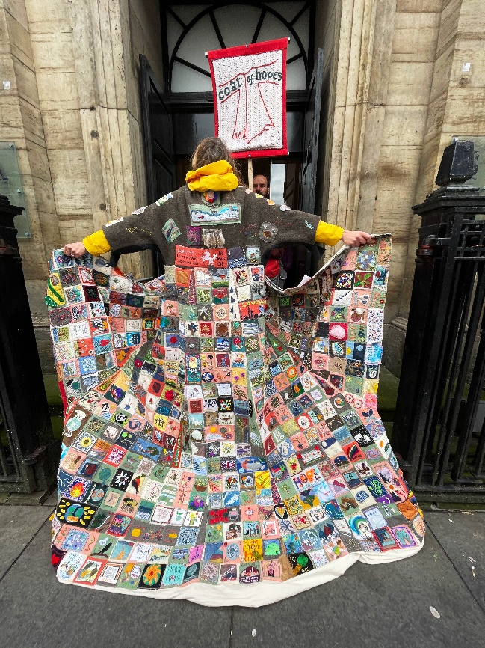

**We invite you to meet with and try the coat on**

**when it comes to Stamford**

**Date:** Tuesday 19th November 2024

**Meeting time:** 2:00 – 3:00 p.m. at St Peter and St Paul, Gt Casterton

4:00 – 5:00 p.m. at Stamford Town Hall

7:00 p.m. Service of Thanksgiving at Stamford URC, Star Lane

Join us to meet, try on the Coat and hear the story and song of **The Coat of Hopes** before we travel on to **Ely** in early December.

Visit our website to find out more: <https://www.coatofhopes.uk/>

**If you would like to walk with the Coat of Hopes, please email yes@coatofhopes.uk**

All are welcome.

**We would love to see you there.**